Birla Institute of Technology & Science, Pilani
Work Integrated Learning Programmes Division
First Semester 2024-2025

Mid-Semester Test
(EC-2 - REGULAR)

Course No. : SS ZG681
Course Title : Cyber Security
Nature of Exam : closed Book
Weightage : 30%
No. of Pages = 2

No. of Questions = 6
Duration : 2 Hours
Date of Exam : 22/09/2024 (EN)
Note to Students:
- Each question carries 5 marks
- All parts of a question should be answered consecutively. Each answer should start from a fresh page.
- Assumptions made if any, should be stated clearly at the beginning of your answer.
________________________________________________________________________

- For each of the following applications, determine which protocols are used and what types of threats are possible in context with the information security. Explain the reason(s) for your choice. [5]
- File Transfer
- Watching a real time streamed video
- Web browsing
- A Voice over IP (VoIP) telephone conversation
- YouTube video

- Explain how BIBA model and Bell–LaPadula model (BLP) supports Integrity and confidentiality. [5]

- Match the fundamental network elements with the correct alternative. [5]

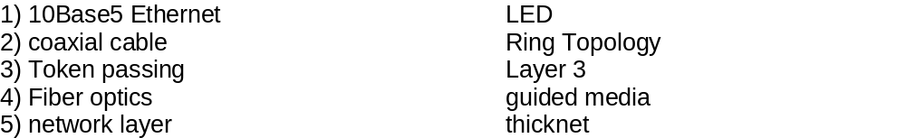

- The addition of short-range radios to both vehicles and highway infrastructure has the potential to significantly enhance the driving experience, providing increased safety and convenience. From a safety perspective, a car that informs other drivers of its sudden deceleration can reduce a ten-car pile-up to a fender-bender, or even prevent the accident entirely. Shared location information could eliminate traditional blind spots and assist drivers during lane changes or merges, potentially preventing thousands of accidents.
For the scenario given above,
(1) analyze the security challenges specific to vehicular networks. [1]
(2) introduce a set of primitives for secure applications. [1]
(3) discuss vehicular properties that can support secure systems. [1]
(4) present two cyber-attacks that can challenge the vehicular properties. [2]

- Suppose you apply for a job for a suitable position in a company, go through the interview process and finally are selected. You join the organization; go through the necessary orientation and training programs before being allocated to projects. For performing your job, if you need access to any resource, your organization’s policy expects you to make requests for getting access to specific resources. Every time you need access to a resource, you need to make an explicit request. What type of security design principle your organization is following? Describe this design principle. Clearly explain the design principle with examples. What happens if this kind of design principle is not followed?

Consider you are a Security Architect in your organization. A complex system has more changes of having security problems. In addition, too complex the system is, too many opportunities for something to go wrong. You would like to create small reusable components for repeated functionality. Which design principle is applicable in this scenario? Describe the design principle. Clearly explain the design principle with an example. [1+1+2+1=5]

- Compare and contrast between Active and Passive attacks with suitable example cases.
[5]

********

